
YEAR 10 SCIENCE

EARTH AND SPACE SCIENCE
(General)

GLOBAL SYSTEMS

NAME:

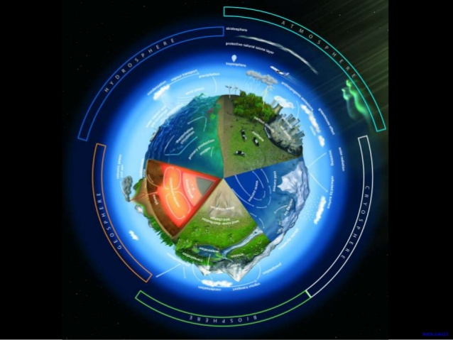

CYCLES IN NATURE

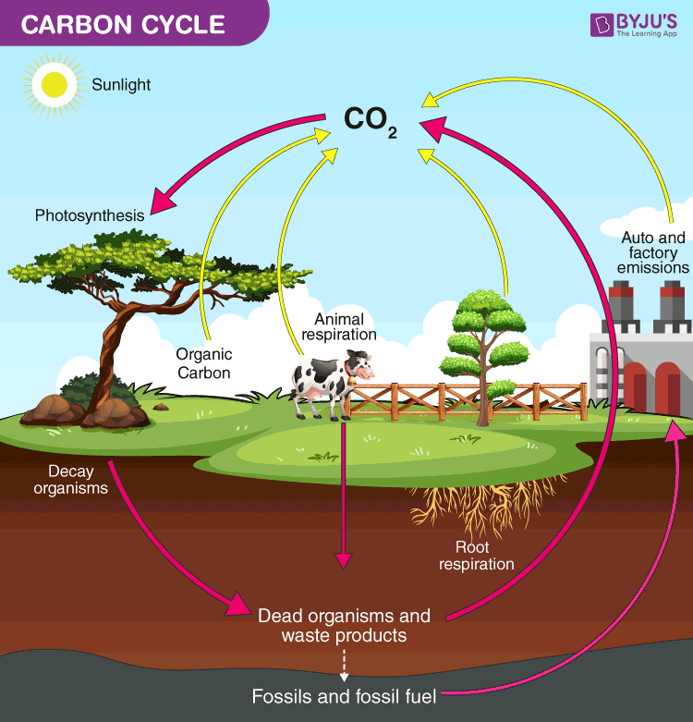
Elements such as carbon, oxygen, hydrogen, nitrogen and sulphur are recycled in nature - this is the role of the decomposers.

Carbon Cycle

The element carbon is one of the main materials in sugars, proteins and fats - these are found in the tissues of all living things. Carbon is also found in vitamins, as well as in waste products such as CO₂ and urea.

In the carbon cycle, plants convert CO₂ to food and O₂ during photosynthesis.

Animals (and plants at night) produce CO₂ during respiration.

On decomposition, all plant and animal material is reduced to CO₂ by the decomposers, and the residual nutrients are returned to the soil.

Nitrogen Cycle

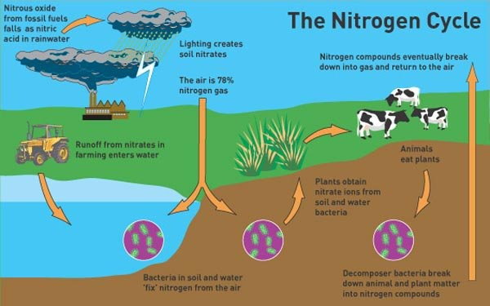
Nitrogen makes up 78% of the atmosphere, is found combined with oxygen as nitrates in the soil, and is one of the elements found in proteins (these are the building blocks of cells and tissues).

Animals obtain their nitrogen either from plants or other animals.

Plants get their nitrogen from the nitrates in the soil. They are soluble in water and are easily absorbed by plant roots.

Nitrates can be formed in the following ways.

• The decay of dead organisms by decomposers.

• Atmospheric nitrogen changed by nitrogen-fixing bacteria in the soil and
in nodules on the roots of legumes such as clover, peas and beans.

• Lightning causes atmospheric nitrogen N₂ to react with O₂ to form oxides
of nitrogen. These form nitrates when they dissolve into water.

Phosphorus Cycle

The phosphorus cycle models how phosphorus moves from the lithosphere to the hydrosphere and then through food chains and back.

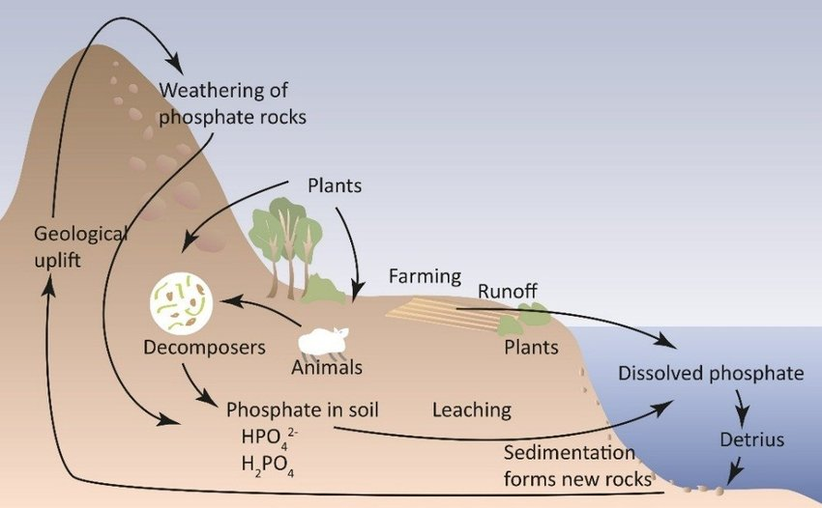

Phosphorus is essential for plant and animal growth, as well as the health of microbes inhabiting the soil, but is gradually depleted from the soil over time. The main biological function of phosphorus is that it is required for the formation of nucleotides, which comprise DNA and RNA molecules. Specifically, the DNA double helix is linked by a phosphate ester bond.

Calcium phosphate is also the primary component of mammalian bones and teeth, insect exoskeletons, phospholipid membranes of cells, and is used in a variety of other biological functions.

The phosphorus cycle is an extremely slow process, as various weather conditions (e.g. rain and erosion) help to wash the phosphorus found in rocks into the soil. In the soil, the organic matter (e.g. plants and fungi) absorb the phosphorus to be used for various biological processes.

Worksheet 7.1

Nature’s time machine
Student: Class:

Secrets in the ice
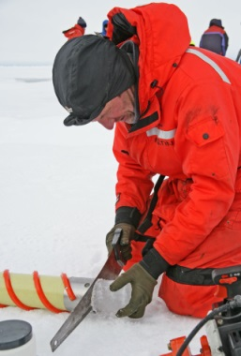
Scientists may not have discovered a time machine yet, but they do have a way of looking back over 300 000 years by looking at ice cores. Scientists drill into the ice of Antarctica and collect samples from deep down. Ice cores provide information about the Earth and the atmosphere over hundreds of thousands of years.
For thousands of years, snow has fallen in Antarctica. The snow turns to ice, which builds up over time. Dust, gases and other substances from the air become trapped in the ice. The trapped substances provide information about what was in the air at the time the snow fell.
By studying dust in the ice cores, scientists can work out when certain volcanoes have erupted. They have linked radioactive substances in the ice to nuclear disasters in various parts of the world. The dust and radioactive substances were probably carried to Antarctica by the wind.
Scientists have used ice cores to track the amount of carbon dioxide in the air and the Earth’s temperature. The graphs on this page show how these have changed over the past 400 000 years.

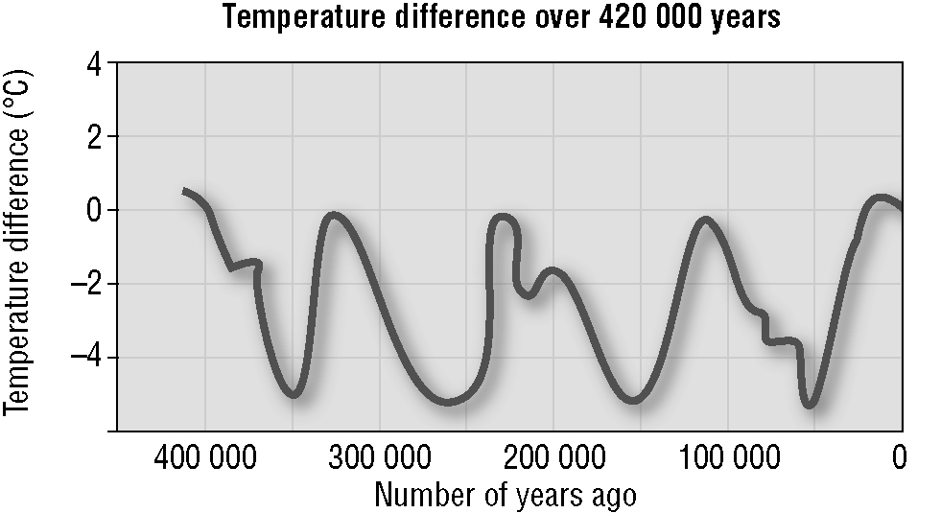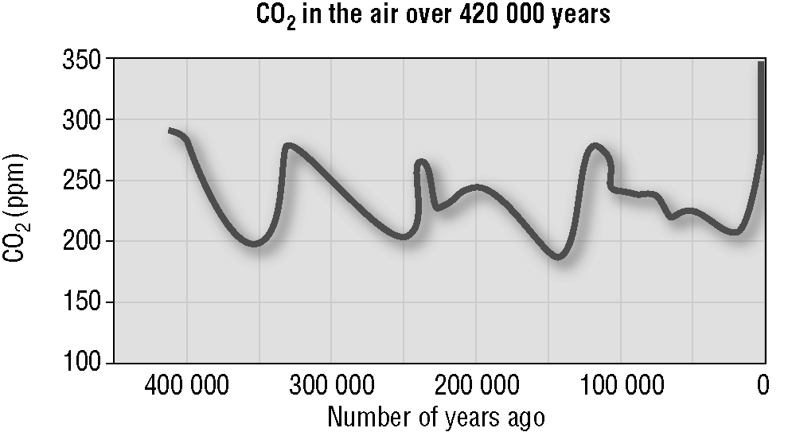
This ice core was drilled from more than 3.7 km down. Parts of it are more than 150 000 years old. Photo: Public domain
Zero on the temperature scale represents the Earth’s average temperature now. On the temperature line, the peaks represent warmer periods of time. In between the peaks, the average air temperature was up to 6°C lower than now. These colder times are called the ice ages.

The line for carbon dioxide resembles the temperature line. When the temperature was higher, there was more carbon dioxide in the air. When the temperature dropped, so did the amount of carbon dioxide. (ppm means parts per million.)

Look at the graphs above of how carbon dioxide and temperature have changed over time and answer the following questions.
1. How many ice ages have there been in the past 400 000 years?
2. At a point 350 000 years ago:
(a) how much carbon dioxide was in the air
(b) how much colder was the Earth’s air compared to the present temperature?
3. Has the Earth ever been warmer than it is now? If so, how much warmer?

4. When was the amount of carbon dioxide in the air the highest?

5. Why is an ice core like a time machine?

Recycling carbon
Carbon atoms are found in the air, soil, rocks, oil and gas below the Earth’s surface, and all living things. The number of carbon atoms on Earth always remains the same. When living things use carbon atoms, the atoms don’t just disappear; they are recycled. The diagram below shows the recycling of carbon. It also shows how humans have added to the amount of carbon dioxide in the air. We must take care not to interfere with the natural recycling process.
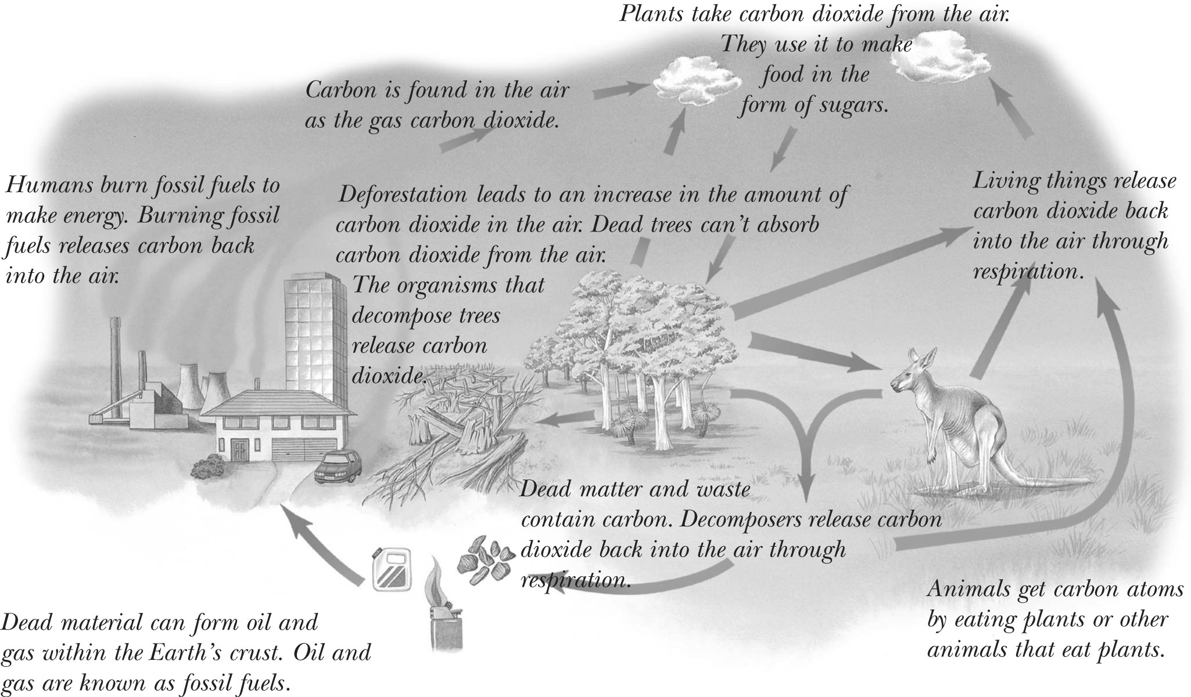
1. How do animals get carbon as part of the carbon cycle?

2. Explain two ways in which carbon that is contained within a plant can end up back in the air.

3. Where in the carbon cycle is carbon stored for long periods of time?

4. Would the carbon cycle still take place if humans did not exist? Explain.

5. How do humans add extra carbon dioxide to the air?

GLOBAL SYSTEMS
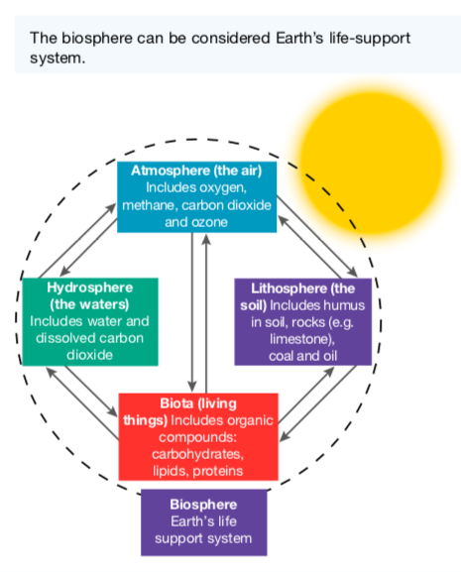
Biosphere

The biosphere consists of the atmosphere, lithosphere, hydrosphere and biota (living things), the interactions between them, and the radiant energy of the sun.

The biosphere includes all of the ecosystems on Earth. Interactions within the biosphere include the cyclical movement of essential elements such as carbon, nitrogen and phosphorus.

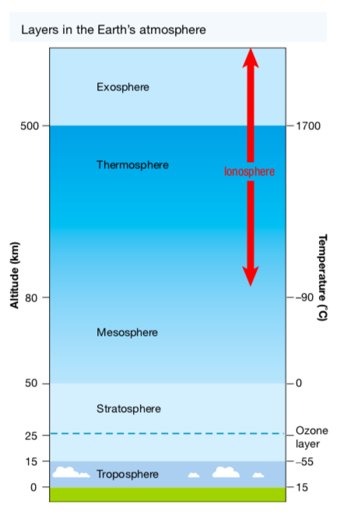
Atmosphere

The Earth’s atmosphere is divided into the troposphere (lower atmosphere) and the stratosphere (upper atmosphere).

The troposphere is around 6-17 km high depending on your latitude (how close you are to Earth’s equator or the poles).

The stratosphere is about 50 km thick and contains an area known as the ozone layer. While this layer allows visible and infra-red radiation from the sun through, it absorbs ultraviolet (UV) radiation. This reduces the amount of damaging UV radiation reaching Earth’s surface.

Chlorofluorocarbons (CFCs) have been used as cooling agents in refrigerators and air conditioners, as propellants in aerosols, and as industrial solvents.

Their use has increased the amount of these com- pounds being released into the atmosphere. Once in the stratosphere, they are broken down into chlorine atoms, which destroy ozone molecules. This has depleted areas of the ozone layer, increasing the amount of damaging UV rays that get through and cause damage to living organisms.
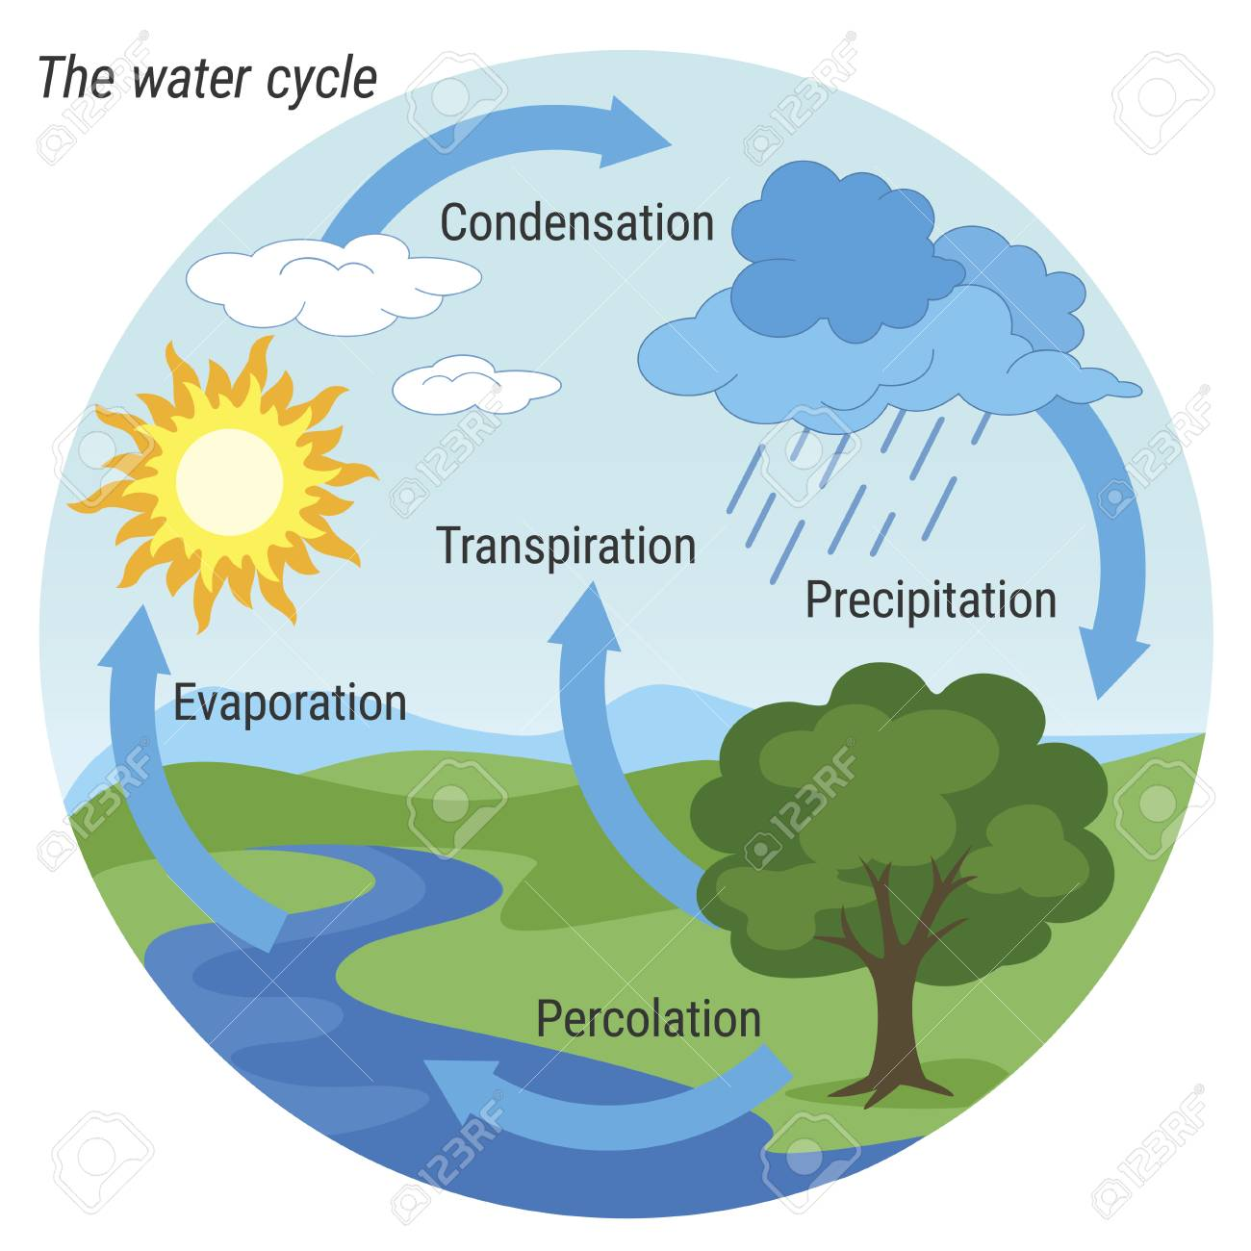
Hydrosphere

The waters of our planet make up the hydrosphere. The simplified figure of the water cycle shown at right describes how water moves through the biosphere.

Toxic or industrial wastes and untreated sewage have made their way into rivers, bays and the ocean, which has had a direct impact on the hydrosphere. Toxins can move along food chains, in some cases being biologically magnified - getting more concentrated - as they move up the chain.

While some of these wastes are purposefully dumped, in other cases they enter the water system in run-off from the land or are washed out of the atmosphere in rain.

Geosphere (Lithosphere)

Earth’s rocky crust and soil make up the lithosphere. It is within this sphere that igneous, sedimentary and metamorphic rocks are formed, broken down and changed from one type to another.
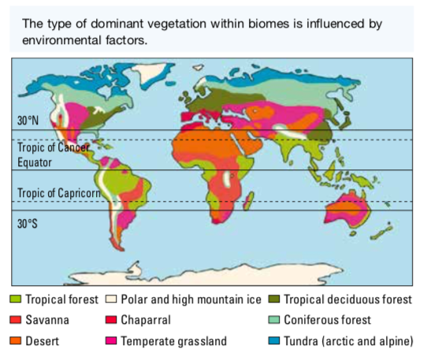
The land surface of our planet is divided into regions called biomes. The criterion used to divide regions into biomes is the dominant vegetation type.

Environmental factors (such as latitude, temperature and rainfall) influence the type of vegetation that can survive in a particular area and so can be used to predict the type of biome that may exist there.

Overstocking, soil exhaustion, salinity, pesticides, unstable landfill, salinisation, toxic seepage, excessive clearing, chemical emissions, deforestation and soil erosion can all be very destructive to the lithosphere. Overgrazing and deforestation may also result in desertification. They can have detrimental effects on habitats and resources and hence the survival of organisms within the ecosystem.

GREENHOUSE EFFECT

Earth’s atmosphere acts like a giant invisible blanket that keeps temperatures on our planet’s surface within a range that supports life. Within the atmosphere, greenhouse gases trap some of the energy leaving the Earth’s surface to help maintain these warm temperatures. The maintenance of Earth’s temperatures by these atmospheric gases is called the greenhouse effect.

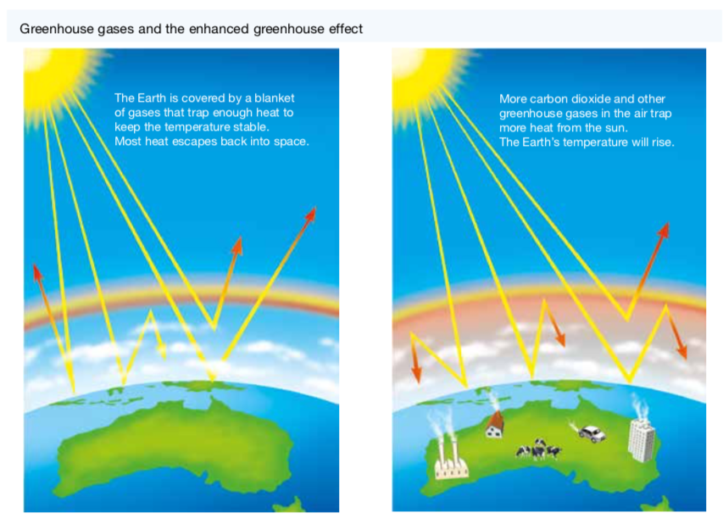

Global Warming

Global temperatures have been increasing and are expected to continue to increase at an accelerated rate. The rising temperature of Earth is known as global warming. This may result in melting icecaps, rising sea levels, increased coastal flooding, unusual weather patterns and ocean currents, and threats to the survival of some living things.

The following diagram summarises the sources of greenhouse gases.

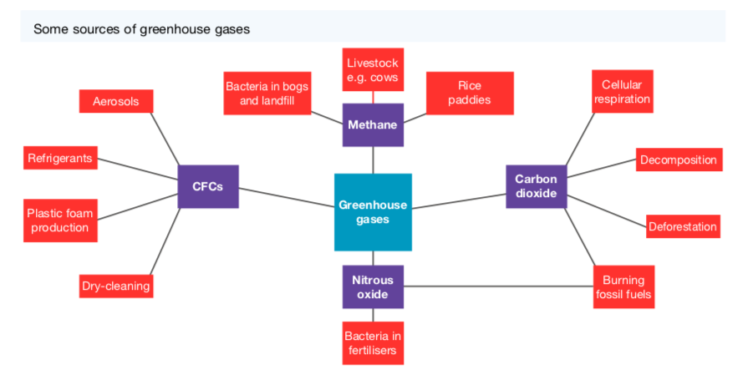
Sources of Greenhouse Gases

• Fossil Fuels

Scientists assert that our increased and growing dependence on fossil fuels since the Industrial Revolution of the nineteenth century is a major cause of global warming. They argue that burning fossil fuels (such as coal and oil) has resulted in increased levels of greenhouse gases (such as nitrous oxide and carbon dioxide) in our atmosphere that are trapping heat, causing the atmosphere to heat up.

This is referred to as the enhanced greenhouse effect.

• Grazing animals

Animals such as cattle and sheep produce large amounts of methane as a waste product.

• Bacteria

Methane is another powerful greenhouse gas and is also produced by the action of bacteria that live in landfills and soils used for crop production.

Much of the nitrous oxide in the atmosphere is produced by the action of bacteria on fertilised soil and the urine of grazing animals.

• Photosynthesis and Cellular Respiration

CO₂ is taken from the atmosphere during photosynthesis and released back during cellular respiration.

This suggests that if producers (plants) are reduced in number or removed from the atmosphere, there will be less carbon dioxide removed from the atmosphere, resulting in an overall increase in this gas.

• Decomposition and Fossil Fuels

Carbon dioxide is also released from dead and non-living parts of ecosystems.

When these fossil fuels are burned, carbon dioxide is released back into the atmosphere.

• Ozone

Ozone (O₃) in the lower atmosphere is also a significant contributor to the enhanced greenhouse effect.

Although ozone occurs naturally, it is also produced by a photochemical reaction that takes place when sunlight falls on emissions from motor vehicles, power stations and bushfires.
Evidence of Global Warming

• Increasing CO₂ Levels

Scientists have used ice cores to track the air temperature and concentration of carbon dioxide near the Earth’s surface in the past. The graphs below show how these have changed over the 420 000 years leading up to the year 2000.

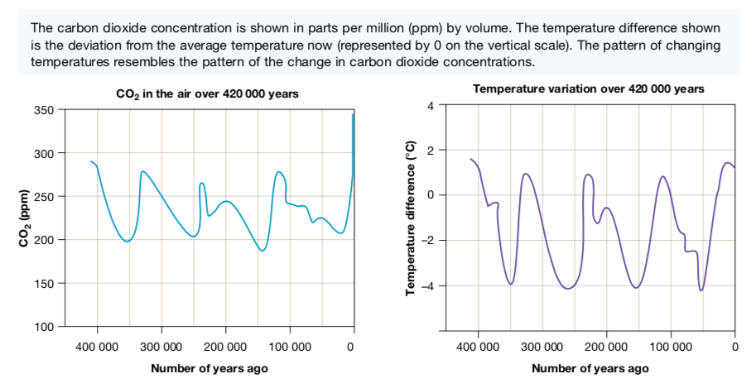

During the current decade the concentration of CO₂ has risen to approximately 400 parts
per million. There appears to be no significant change in global temperature cycles.

However, the graph below shows that since the Industrial Revolution, there has been a dramatic change in the trend of carbon dioxide in the atmosphere.

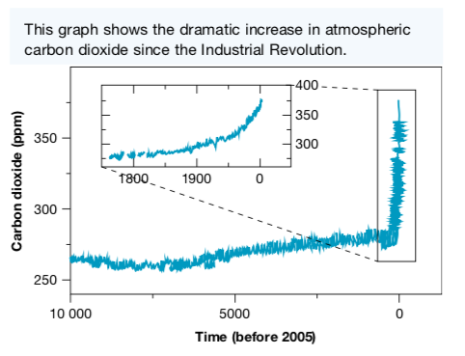

• Climate Models

Meteorologists and other scientists use computer modelling to make predictions about
climate change and the possible consequences.

The computer programmes used to model climate change simulate the circulation of air in the atmosphere and water in the oceans. An immense amount of data collected from the atmosphere, ocean and land surface is used, together with mathematical equations that describe the circulation.

• Global Temperature

It is generally agreed that during the next 100 years, the average global temperature could increase by between 1 °C and 4 °C. Computer modelling suggests that the global temperature will not increase evenly across the continents.

According to CSIRO in Australia, temperatures could increase by up to 2 °C by 2030 and up to 6 °C by 2070. As a consequence, there will be:

• more hot days and fewer cold days
• an increase in rainfall in the north-east and a decrease in the south
• more bushfires
• more destructive tropical cyclones

• Rising Sea Levels

According to tide-gauge records, the average global sea level has increased by between 10 cm and 20 cm during the past 100 years.

Sea levels are expected to rise further due to:

• the warming ocean water and its resulting thermal expansion
• the melting of glaciers, the polar ice- caps and the ice sheets of Greenland and Antarctica.

According to NASA, sea ice in the Arctic is melting at the rate of 9 % every ten years. Of the world’s 88 glaciers, 84 are receding due to melting ice.

Rising sea levels are likely to cause the flooding of low-lying islands and coastal regions.

• Frozen Soil

Much of the soil on or below the surface of very high mountains in the polar regions is permanently frozen - called permafrost.

This soil is likely to gradually thaw out as global air temperatures increase, potentially releasing large quantities of CO₂ and methane will be released into the atmosphere. This would increase the rate of climate change.

BIODIVERSITY AND CLIMATE CHANGE
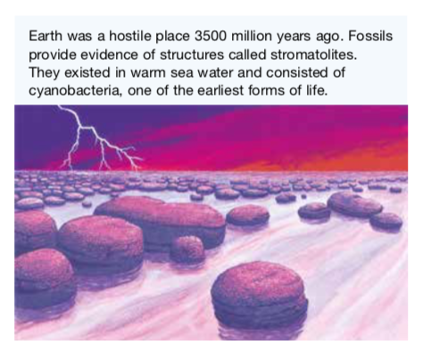
The evolution of life forms on Earth has occurred because some organisms are better suited to a particular environment than others.

For some to be better suited than others, there needs to be variation or diversity.

In a global sense, biodiversity refers to the total variety of living things on Earth, their genes and the ecosystems in which they live.

Species Diversity

All environments change over time.

It is the diversity (or variation) of the genetic information within the "gene pool" that contributes to the number of possible combinations that could be used to produce the next generation.

Increased variety in how this genetic information appears in the offspring (i.e. their traits) means an increased chance that some of these offspring will be able to survive in the environment in which they are born and will live - even if that environment changes.

If there is little variation in the gene pool, there is less chance of the offspring being able to survive possible changes in their environment, such as climate and the availability of habitat, food, mates or other resources.

The consequences of this limited diversity within the population may lead to the extinction of the species.

Ecological Diversity

Ecological diversity can be considered in terms of the diversity in ecosystems.

The extinction of a particular species within an ecosystem may affect the survival of other species within that ecosystem.

e.g. The extinct species’ disappearance will have consequences for the food supplies of others within its food web.

Unless there are other species that can take its place without having a negative effect on others, the survival of other species may be threatened.

Increased biodiversity within ecosystems can reduce the consequences of losing a species to which the survival of others is linked. Likewise, reduced biodiversity in these ecosystems can lead to the extinction of other species.

AUSTRALIA'S BIODIVERSITY

Biodiversity within Australian ecosystems is influenced by both biotic factors (e.g. plants and animals) and abiotic factors.

• Abiotic factors - those that contribute to climate (e.g. temperature and annual rainfall) can affect the abundance, distribution and types of species within a particular ecosystem.

Organisms have particular tolerance ranges for abiotic factors, outside of which they cannot survive.

If global warming results in the development of climatic conditions that are outside a species’ tolerance range, and if they are unable to migrate or adapt to the new conditions, then there is a threat that the species may become extinct.

Species that are most at risk are those that have:

• low genetic variability
• long life cycles and low fertility (birth rates)
• a narrow range of physiological tolerance and geographic range
• specialist resource requirements

Global Warming and Australia’s Biodiversity

Changes in Australia’s biodiversity that may be due to climate change include:

• changes in species’ ranges and migration patterns
• shifts in genetic composition of some species that have short life cycles
• changes in lifestyle and reproduction rates

Example

Many plants and their pollinators have coevolved - they rely closely on each other.

Studies show that climate change has upset the life cycles of pollinators (such as bees). Other studies show that climate change is causing the flowering times of some plants to be out of synchronisation with their pollinators.

With fewer plants being pollinated, fewer are bearing fruit containing seeds essential to produce the next generation of plants.

Preparing to Adapt to Unavoidable Climate Change

The National Climate Change Adaptation Research Facility (NCCARF) has identified eight priority areas for adaptation research. These are:

• terrestrial biodiversity
• primary industries
• water resources and fresh-water biodiversity
• marine biodiversity and resources
• human health
• cities and infrastructure
• emergency management
• social and economic issues

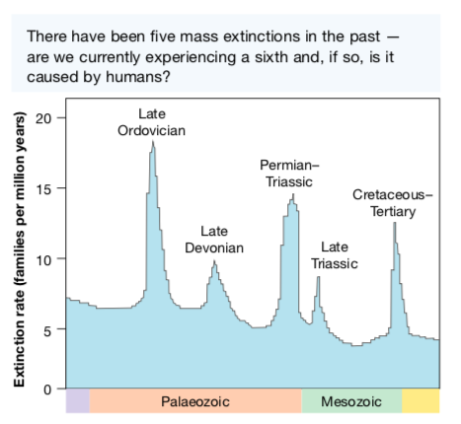
Mass Extinctions

Many scientists believe that we are currently experiencing the sixth mass extinction.

Five other mass extinctions have occurred as a result of global climate change. Some argue that humans are responsible for the current mass extinction.

The International Union for Conservation of Nature has reported that species are dying out 1000 to 10,000 times faster than they would without human intervention.

Those with the view that humans are to blame
divide this sixth extinction into two phases.
• The first phase began about 100,000 years ago
when the first modern humans began to spread throughout the world.
• The second phase began when humans started to use agriculture around
10,000 years ago.

